Annual Reappointment Instruction TOOL

Reappointment of Annual Faculty Appointments: due by Friday April 29, 2016

Instructor, Lecturer, and Corresponding Member of the Faculty titles are annual faculty appointments that need to be confirmed before May each year for reappointment on July 1.

You will find an Excel report on MARS titled Review of Annual Appointments Instructors/Lecturers Report that facilitates this process. This report is designed to expedite the processing of this large volume of reappointments which is reviewed and processed by the Office for Faculty Affairs. The data in the RAAP output serves 3 purposes:

- To confirm the reappointment for those appointees to be reappointed for the new academic year effective July 1.
- To collect termination information for those appointees who have left or will be leaving.
- To enable Faculty Affairs to update faculty records with important teaching and faculty development information using the spreadsheet downloaded from MARS to upload into our systems.

RAAP reports must be completed and sent to our office as an Excel file by Friday April 29.

There are separate reports for non-faculty academics and term reappointments, as listed below:

Term Reappointments (due to Faculty Affairs) | Review of Non-Faculty Academic Appointments (due to Human Resources)
- Assistant Professors, Full-time and Part-time | - Research Associates, Associates
- Associate Professors, Full-time and Part-time | - Research & Clinical Fellows
- Professors, Part-time

All faculty appointments require a minimum of 50 hours of teaching per year in the Harvard community, and we are required to document the scheduled teaching activity of annual faculty on an annual basis. If you are unable to document teaching for a faculty member in 2016, you should either terminate the appointment or place the faculty member on a leave if applicable. HMS accreditation policy requires that we monitor, enforce, and document this requirement.

Accessing the RAAP Report on MARS
MARS (Medical Area Reporting System) can be accessed via this direct link or from the Applications box on the eCommons home page, after log in.

- From MARS, click on the MAIN MENU in the crimson banner at the left hand top of the page.
- On the next screen you will see the link for HR PeopleView on the left and HR Reports on the right. Click on HR Reports.
- Click on EMPLOYEE and JOB LISTS.
- Click on Review of Annual Appointments Instructors/Lecturer.
Running the RAAP Report

Running RAAP for Instructors/Lecturers/Corresponding Members of the Faculty
RAAP is designed to report out any Instructor, Lecturer, or Corresponding Member of the Faculty with an end date between your run date and December 31 of the current calendar year.

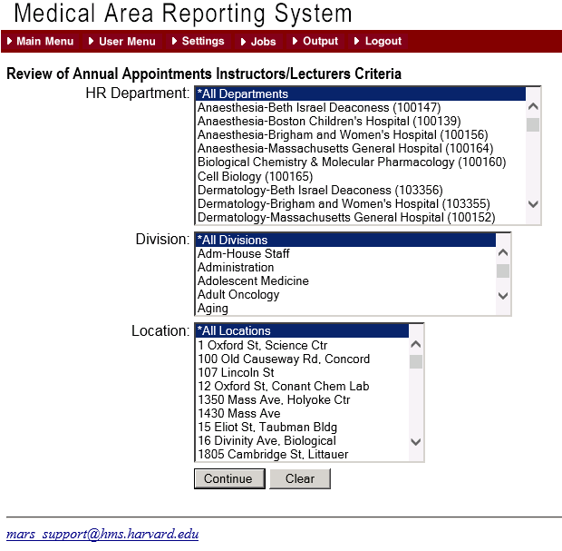

Step 1: Select your department from the drop down list.
The report may also be run by division if your department has reported division data to us
The report may also be run for a specific location
Click Continue

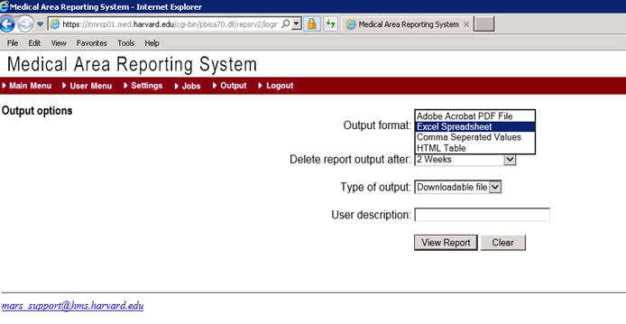
Step 2: Format the Output
Choose Excel Spreadsheet from the drop down menu as the Output Format.
(Leave the Type of Ouput and User Description defaults as is)
Click ‘View Report’.

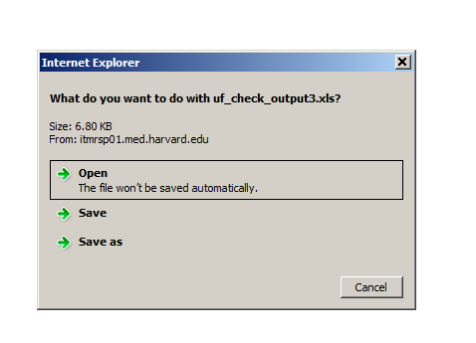
Step 3: Save your RAAP file to your computer
When MARS has completed the Term Reappointment file you will see a dialog box asking to open or save the file.
Save to your computer using the following naming convention:
DEPARTMENT NAME.LOCATION.TERM:
Examples:
Medicine.BWH.Term.xlsx
CellBiology.HMS.Term.xlsx

Please Note:
The MARS Excel output will be version 1997-2003 xls. You may need to save as .xlsx depending on your computer’s operating system.

Collecting the Data
The RAAP spreadsheet lists all current Instructors and/or Lecturers, both full-time and part-time and any Corresponding Members of the Faculty, who have an end date between the day you run the report and December 31 of the current calendar year. The majority will have a June 30th end date.

Use the Excel spreadsheet to identify reappointments and terminations, record teaching and mentor information, and submit to OFA for action. The Teaching Categories you use for reporting teaching activity (in hours per year) are:

- Teaching of Students in Courses (can be Harvard Medical, Dental, Masters, Doctoral or Undergraduate Students)
- Formal Teaching of Residents, Clinical Fellows and Research Fellows (post-docs)
- Clinical Supervisory and Training Responsibilities
- Laboratory and Other Research Supervisory and Training Responsibilities
- Formally Supervised Trainees
- Formal Teaching of Peers (e.g., CME and other continuing education courses)
- Local Invited Presentations at a Harvard affiliated institution
- Mentoring Trainees and Peers
- Educational Administration and Service

You may sort your Excel spreadsheet by Job Code Description, Location, or any other sort that will assist you in completing the process.
You may also expand the columns width and wrap column headings or hide columns to assist you while you work

Please unhide any columns you have hidden and unfreeze any panes you have locked when you are finished and prior to submitting to our office

Do not delete or move any of the columns. It is most important not to modify any of the data in columns A through T. If data are changed in these columns, your reappointments and terminations will not upload into our systems

Modifications to data in those columns, such as title, location, etc., must be done via eTad.

In this sample (with dummy data), we have sorted by Job Code Description (the short title) and then by last name:
New in 2016!

Do not modify any of the data or formats in columns A through T

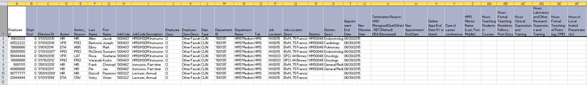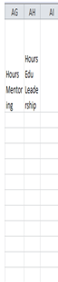

Please use column AI for any comments or special instructions you wish to communicate with our office

To Reappoint Instructors

- Do not delete or change any data in columns A through T. Column X is not applicable to this process
- Enter the New Appointment End Date 6/30/2017 in column W
- Complete the information for columns Y through AH to satisfy the annual documentation for Instructors
(Mentor and Conference data are not required for Lecturers, but teaching hours should be reported for all ranks)

Sample:

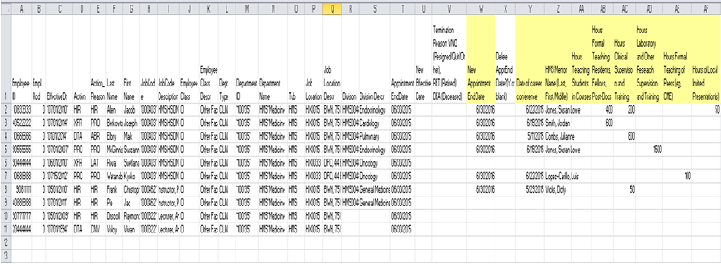

Helpful Hints:
- Reappointment should always be through June 30 of the following year
- If someone is in the process of being promoted, reappoint so they remain active during the promotion process

To Reappoint Lecturers and Corresponding Members of the Faculty

- Do not delete or change any data in columns A through T. Column X, Y, and Z are only applicable to Instructors
- Enter the New Appointment End Date 6/30/2017 in column W
- To satisfy the annual teaching requirement for Lecturers, complete the information for columns AA through AH.
- Corresponding Members of the Faculty may be contributing to your department in other ways than teaching. They are the only rank that might reflect 0 teaching hours. However, please make sure you indicate you wish to reappoint them for the upcoming year, otherwise indicate the termination reason in column Y and effective date in column T.

Sample:

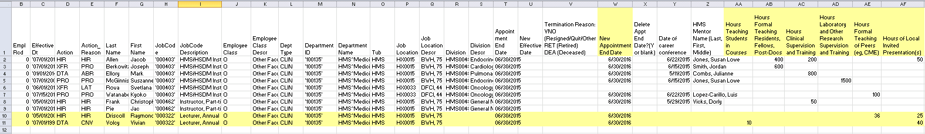

Helpful Hints:
  - Reappointment should always be June 30 of the following year
  - Lecturers and Corresponding Members of the Faculty do not require a career conference or a HMS Mentor name
To Terminate an Instructor, Lecturer or Corresponding Member of the Faculty
Timely reporting of faculty and appointees who have left Harvard is very important as many other business processes rely on this information.
- Enter the effective date of the termination in the ‘New Effective Date’ column U.
Examples:
  - If an appointee is due to leave on June 30 fill in 07/01/2016 in the ‘New Effective Date’ column U.
  - If an appointee is due to leave on September 14 fill in 9/15/2016 in the ‘New Effective Date’ column U.

- If an appointee has left or will be leaving the Hospital/HMS enter the 3 character reason code in column V.
  - VNO if the person has Resigned, Quit, or Other reason
  - RET if the appointee has Retired
  - DEA if the appointee is Deceased

Sample of a completed spreadsheet for all actions:
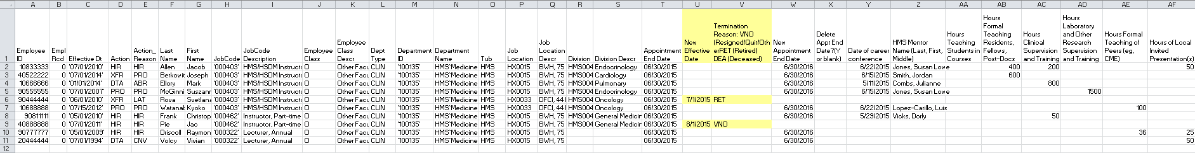

Submitting to OFA

Return the RAAP sheets no later than April 29, 2016 using the following naming convention:

DEPARTMENT NAME.LOCATION.INSTRUCTORS

Please email to facappt@hms.harvard.edu, with a cc to your appointing department head.
Please be advised that your cc of the appointing department head constitutes his/her approval of the reappointments included on the spreadsheet. Without this cc we cannot process these reappointments.

For more information concerning your annual faculty reappointments, please contact us at:
- facappt@hms.harvard.edu, or
- call 617/432 2702 to speak with Katie Chasson or Greg Demetriou, or
- call 617/432 3178 to speak withYvette Jusseaume.

If you are the principal administrator of annual reappointments for your department and need access to MARS to run this report, please contact Jennifer Galbraith Ryan at jennifer_ryan@hms.harvard.edu

