Reappointment Instruction TOOL
Reappointment of Term Appointments: due by Monday September 5, 2016

Term faculty appointments are for 3 or 5 year intervals and require review and action by the appointing department.
The following titles are considered term appointments:
- Professor, Part-time (5 year term)
- Associate Professor; Associate Professor, Part-time (5 year term)
- Assistant Professor; Assistant Professor, Part-time (3 year term)
- 3 yr Lecturer (3 year term)
- 3 yr Senior Lecturer (3 year term)
- Principal Associate (3 year term)

To facilitate this process you will find an Excel report on MARS titled Term Reappointments List. This tool identifies term faculty requiring reappointment this year, and the report will include any senior or junior faculty level appointment with an end date between your run date and December 31 of the current calendar year. It also provides you space to record the hours of teaching at Harvard over the past academic year, as well as the faculty member’s mentor name and the date of the last annual career conference with the mentor.
If you are the principal administrator of term reappointments for your department and need access to MARS to run this report, please contact Jennifer Galbraith Ryan at jennifer_ryan@hms.harvard.edu
Reminder: All faculty appointments require a minimum of 50 hours of teaching Harvard learners per year under one or more of these categories:
- Teaching of Students in Courses
- Formal Teaching of Residents, Clinical Fellows and Research Fellows (post-docs)
- Clinical Supervisory and Training Responsibilities
- Laboratory and Other Research Supervisory and Training Responsibilities
- Formally Supervised Trainees
- Formal Teaching of Peers (e.g., CME and other continuing education courses)
- Local Invited Presentations
- Mentoring
- Administrative Teaching Roles.

Documents Needed to Process a Term Reappointment

Please find detailed reappointment policies for term faculty on the Faculty Affairs website at: http://www.fa.hms.harvard.edu
The documentation required for reappointment of term faculty is:
- Department Head letter (you may use the new Term Reappointment Template) summarizing the appointee's accomplishments during the past term to include:
  - Name of faculty mentor and date of last annual conference.
  - An assessment of the level of productivity, the quality of the contributions, and the teaching activities.
  - A statement describing the source of funds to support the reappointment.
  - A statement of integrity and professionalism:
    - This candidate is a faculty member in good standing with an appropriate hospital appointment and associated credentialing. To the best of my knowledge, other than as may be indicated herein, the candidate has not been sanctioned or disciplined by a hospital, state licensing board, the NIH, the FDA, or any other legal, regulatory, or institutional authority. There are no pending or closed investigations or other concerns known to me that raise questions about the candidate’s integrity, professionalism, competence, interactions with colleagues, or the quality of the candidate’s contributions as a member of the Faculty of Medicine of Harvard University.
  - Note: Professor reappointment packets must also include 3 letters of support from individuals inside Harvard and 3 letters of support from external sources.

- C.V. & Bibliography in Harvard Format

There are two ways to submit your term reappointment documents, both in pdf format, using the following naming convention for each faculty packet:
LastName, FirstName MI.Rank.2015reappt. (eg: Smith, John B.Asst Prof.2015reappt)
Rank Convention: Prof, AssoProf, AsstProf, 3ySrLect, 3yLect, PrAsso
- (Preferred method) Place your pdf packets of documents once you have completed the packets, titled as indicated above, in the eCommons Collaborative Folder (between OFA/Your Department). To access this folder, you must log into eCommons, find the Applications Menu, and click on Online Storage. Find and click on My Collaborations on the top left of the eCommons screen. Place your document(s) in your department’s OFA shared folder.
- (Alternate method) Email your pdf packet of documents, titled as indicated above, to the OFA FACAppt account (facappt@hms.harvard.edu)

Use the term reappointment report (excel spreadsheet) to:
- Record the teaching hours under the appropriate column on the term reappointment spreadsheet for each faculty member being reappointed.
- Record the name of the faculty mentor and the date of the last annual conference held with the mentor.
Accessing the Term Reappointment Report

Accessing the Term Reappointment Report on MARS :
MARS (Medical Area Reporting System) can be accessed via this direct link or from the Applications box on the eCommons home page, after log in.
- Once on MARS click on the MAIN MENU in the crimson banner at the left hand top of the page.
- On the next screen you will see the link for HR PeopleView on the left and HR Reports on the right. Click on HR Reports.
- Click on EMPLOYEE and JOB LISTS.
- Click on Term Reappointments List.
Running the Term Reappointment Report

Running the Term Reappointments List
This report is designed to report out any Senior or junior faculty level appointment with an end date between your run date and December 31 of the current calendar year.
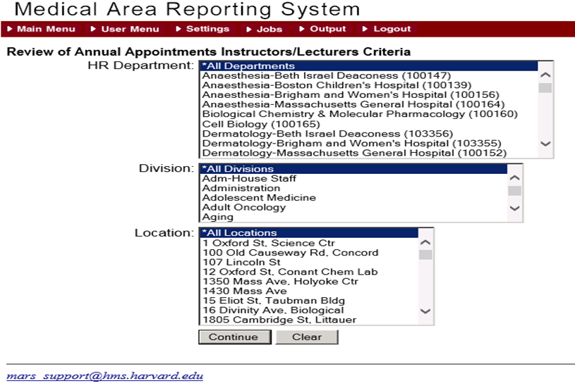

Step 1: Select your department from the drop down list
The report may also be run by division if your department has reported division data to us
The report may also be run for a specific location
Click Continue

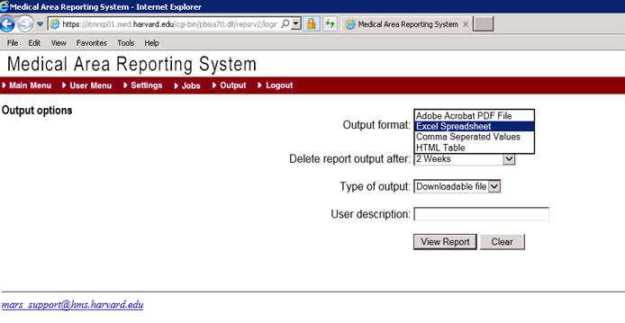
Step 2: Format the Output
Choose Excel Spreadsheet from the drop down menu as the Output Format
(Leave the Type of Ouput and User Description defaults as is)
Click ‘View Report’.

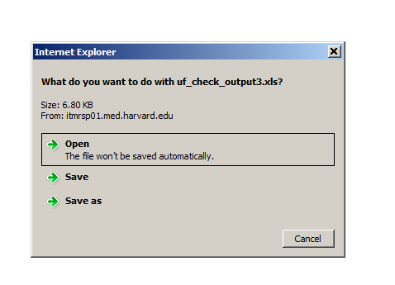
Step 3: Save your Term Reappointments file to your computer
When MARS has completed the Term Reappointment file you will see a dialog box asking to open or save the file.
Save to your computer using the following naming convention:
DEPARTMENT NAME.LOCATION.TERM:
Examples:
Medicine.BWH.Term.xlsx
CellBiology.HMS.Term.xlsx

Please Note:
The MARS Excel output will be version 1997-2003 xls. You may need to save as .xlsx depending on your computer’s operating system.

Collecting the Data
The Term Reappointments spreadsheet will list all current senior and junior level faculty appointments, both full-time and part-time, with an end date between the day you run the report and December 31 of the current calendar year. The vast majority will reflect an October 30th end date.
Use the Excel spreadsheet to identify reappointments and terminations, record Date of the last Career Conference (column Y), HMSMentor Name (column Z) and the required teaching information (columns AA through AH), and submit to OFA for action. Please use column AI for any special notes or instructions. (for example:on leave from 1/1/16-6/30/16)
You may sort your Excel spreadsheet by Job Code Description, Location, or any other sort that will assist you in completing the process. You may also expand the columns width and wrap column headings. It may be helpful to hide columns you will not be entering data into. However, please ensure you unhide and undo any views before you submit this data to us.
Do not delete or move any of the columns. Please do not change any data in columns A through T. Changes to information in those columns, such as title, location, etc., must be done via eTad.
In this sample (with dummy data), we have sorted by Job Code Description (the short title) and then by last name:

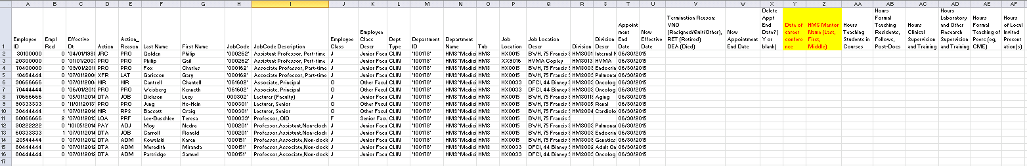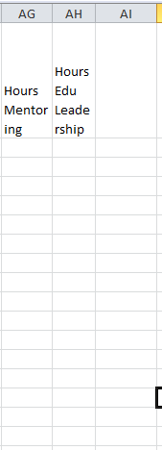

To Reappoint:
- Do not delete or change any data in columns A through T. Column X is not applicable to the Term reappoint process
- Enter the New Appointment End Date, 10/30/2019 for a 3 year term and 10/30/2021 for a 5 year term, in column W
- Complete the information for columns Y through AH
- Upload the supporting documentation, as one pdf, for each faculty reappointment to the collaborative folders or send it to facappt@hms.harvard.edu
Helpful Hint:
- If someone is in the process of being promoted at the time you run this report and submit this data, reappoint so they remain active during the promotion process
To Terminate:
Timely reporting of faculty and appointees who have left Harvard is very important as many HMS business processes rely on this information.
- Enter the effective date of the termination in the ‘New Effective Date’ column U
Examples:
  - If an appointee is due to leave on June 30 fill in 07/01/2016 in the ‘New Effective Date’ column U
  - If an appointee is due to leave on September 14 fill in 9/15/2016 in the ‘New Effective Date’ column U

- If an appointee has left or will be leaving the Hospital/HMS enter the 3 character reason code in column V
  - VOL if the person has Resigned, Quit, or Other reason
  - RET if the appointee has Retired
  - DEA if the appointee is Deceased
Submitting to OFA

Return the Term Reappointments by September 5, 2016
Send the completed Term Reappointments List as an Excel file titled DEPARTMENT NAME.LOCATION.TERM (eg: Medicine.BWH.Term) and completed with Teaching Hours, Faculty Mentor and Annual Conference information, and send/upload the supporting document for each appointment. Send the Excel file which summarizes all the appointments via email to facappt@hms.harvard.edu with a cc to your appointing department head (or his/her formally appointed designee) as shown in the example below. Please be advised that your cc of the appointing department head constitutes his/her approval of the reappointments included on the spreadsheet. Without this cc we cannot process these reappointments.
For more information concerning your term faculty reappointments, please contact us at: facappt@hms.harvard.edu, or call at 617/432 2702 to speak with Katie Chasson or Greg Demetriou, or 617/432 3178 to speak with Yvette Jusseaume.

