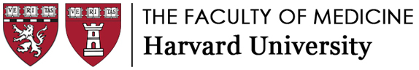

Department Transfer Request Form
This form is to be used when a faculty member is ending their HMS/HSDM appointment in one appointing department in the Faculty of Medicine and starting another HMS/HSDM appointment in another appointing department within a 6-month time period, whether or not the faculty member is staying within the same affiliate.

What is the rationale for the change in department?

Has the current department head passed on relevant information to the proposed new department head regarding factors relevant to the candidate’s academic appointment (e.g., career support, promotion guidance, and matters of integrity and professionalism)? If not, please explain.

This candidate is a faculty member in good standing with an appropriate hospital, Basic Science or Social Science Department, and/or HSDM appointment and associated credentialing, as relevant. To the best of my knowledge, other than as may be indicated herein, the candidate has not been sanctioned or disciplined by a medical school or other institution of higher education, a hospital, a state licensing board, the NIH, the FDA, or any other legal, regulatory, or institutional authority. There are no pending or closed investigations or other concerns known to me that raise questions about the candidate’s integrity, professionalism, competence, interactions with colleagues, or the quality of the candidate’s contributions as a member of the Faculty of Medicine of Harvard University.

_________________________________ ______________________________
Current Department Head Proposed New Department Head
(signature and date required) (signature and date required)

